Quiz 03

The CDA has decided to use small teams to administer the COVID-19 vaccine to the residents of Islamabad at key locations in the city. The location map is shown in the figure, where location O is the entry point and location T is the exit point, and the numbers show the distance between the locations.

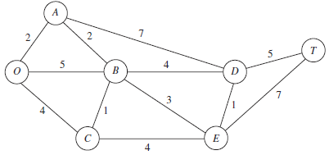

The problem is to determine the shortest route from location O to location T.

1. What kind of network model fits this problem? Shortest path problem
2. Translate this problem into a minimum cost flow model.

